Brianna Stamas

PHYS 410: Scientific Programming

Sprint 2016

Assignment 7

1. Ice Core data
2. Basics
   1. There are 3311 lines. I converted the file to a csv then appended each row to the corresponding column lists. I took the length of the depth list.
   2. 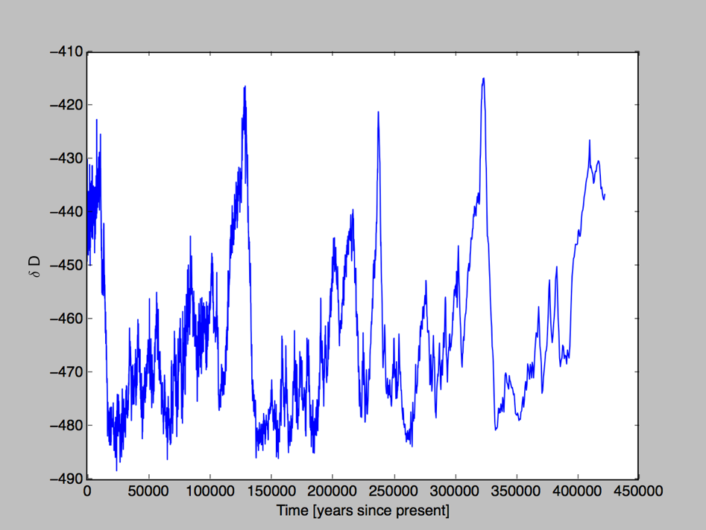

There are periods of high and low deuterium content of ice, it appears to be periodic.

* 1. 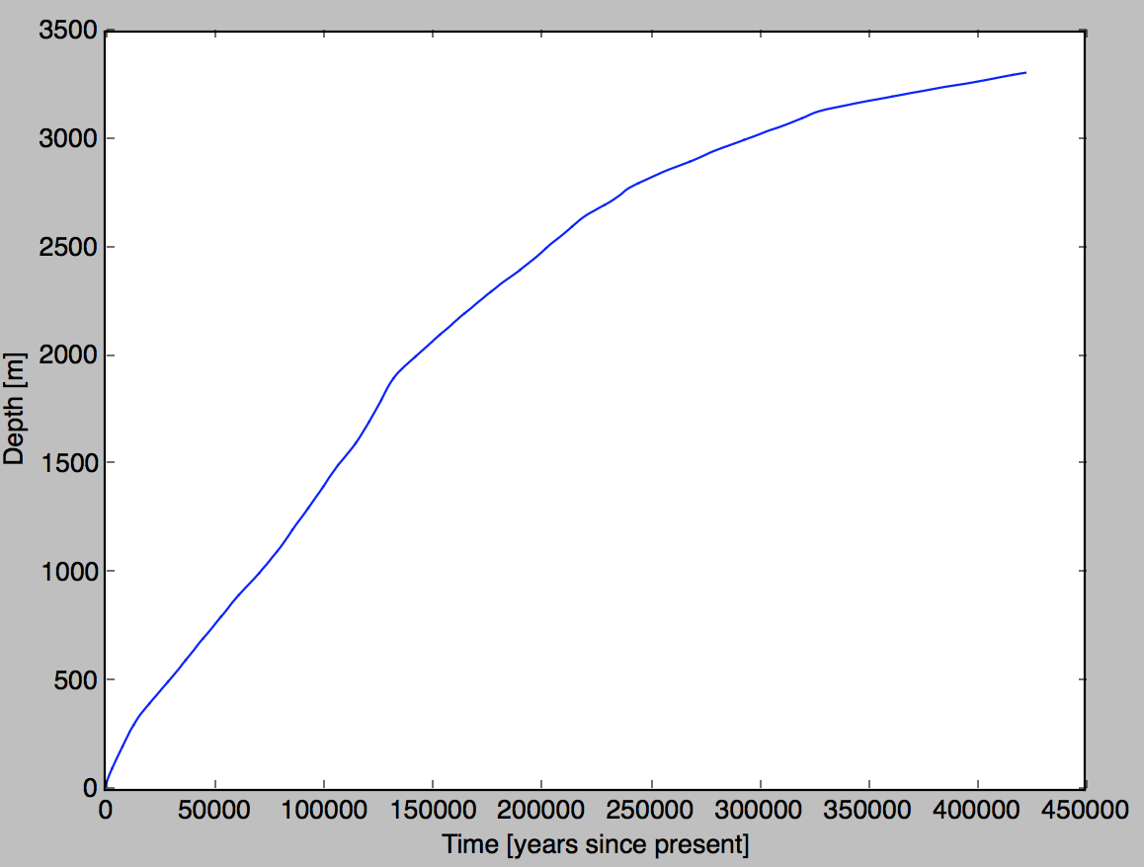

Since the depth as a function of time is not linear, this show that the data are not event spread out in time.

1. For N=7 the length of the the interpolated data is 128.

For N=11 the length of the interpolated data is 2043.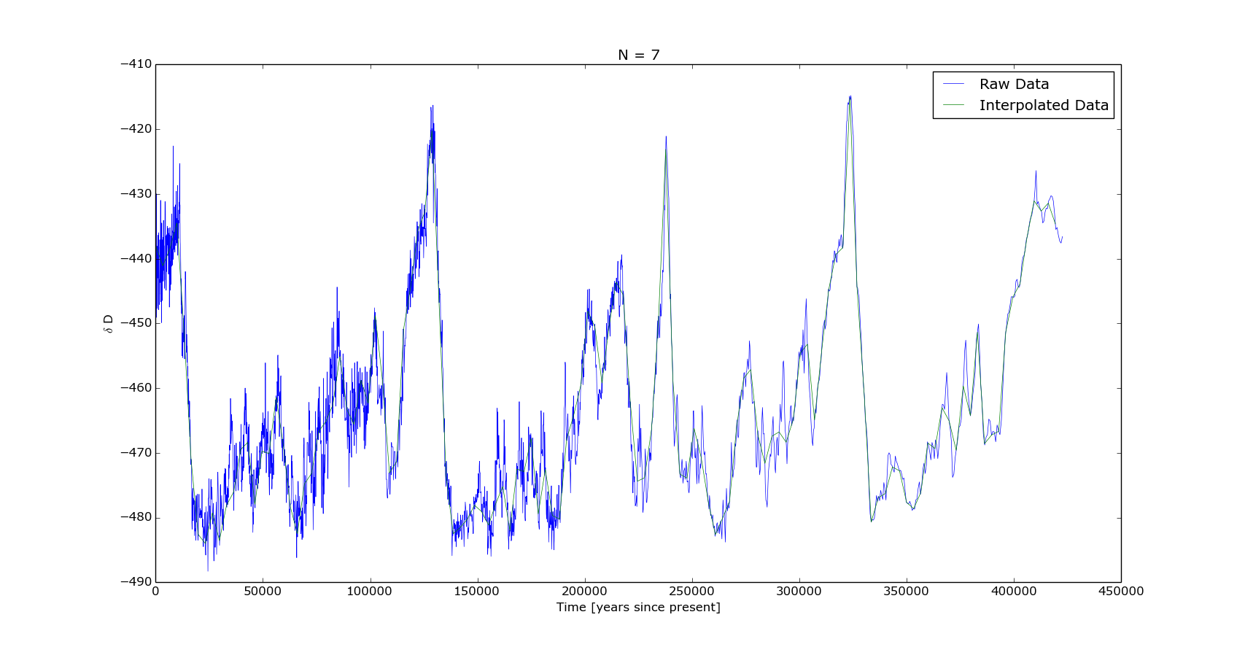

For N=15 the length of the interpolated data is 32521.